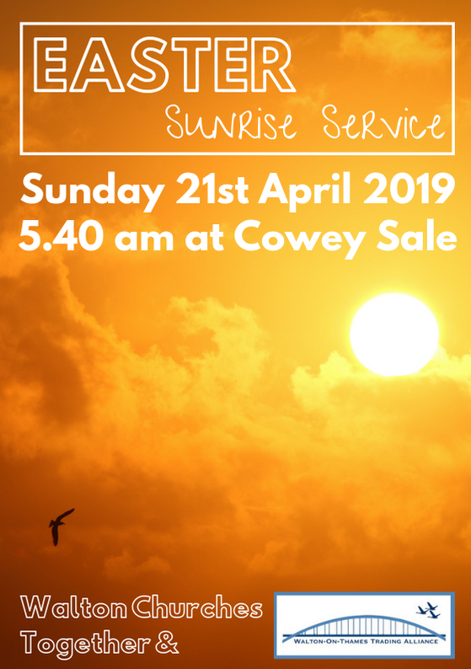
Please join in with the words in bold type

WELCOME by Rev Jonny Blair

WE SING
When I survey the wondrous cross
on which the Prince of glory died,
my richest gain I count but loss,
and pour contempt on all my pride.

Forbid it, Lord, that I should boast,
save in the death of Christ my God:
All the vain things that charm me most,
I sacrifice them to His blood.

See from His head, His hands, His feet,
sorrow and love flow mingled down:
Did e'er such love and sorrow meet,
or thorns compose so rich a crown?

Were the whole realm of Nature mine,
that were an offering far too small;
Love so amazing, so divine,
demands my soul, my life, my all!

Isaac Watts

READINGS Genesis 22: 1-18
Isaiah 53: 1-12
Psalm 22: 1-5

And the end of each reading, we use the following response:
Reader This is the word of the Lord
All Thanks be to God

WE SING
There is a green hill far away,
Outside a city wall,
Where the dear Lord was crucified,
Who died to save us all.

We may not know, we cannot tell,
What pains He had to bear;
But we believe it was for us
He hung and suffered there.

He died that we might be forgiven,
He died to make us good,
That we might go at last to heaven,
Saved by His precious blood.

There was no other good enough
To pay the price of sin;
He only could unlock the gate
Of heaven, and let us in.

O dearly, dearly has He loved!
And we must love Him too,
And trust in His redeeming blood,
And try His works to do.

READING John 20: 1-20

Reader This is the word of the Lord
All Thanks be to God

EASTER ACCLAMATION

Minister Alleluia. Christ is risen.
All He is risen indeed. Alleluia.
Minister Praise the God and Father of our Lord Jesus Christ:
All he has given us new life and hope
by raising Jesus from the dead.
Minister God has claimed us as his own:
All He has made us a light to the world.
Minister Alleluia. Christ is risen.
All He is risen indeed. Alleluia.

WE SING
Thine be the glory, risen, conquering Son;
Endless is the victory, Thou o'er death hast won.
Angels in bright raiment rolled the stone away,
Kept the folded grave-clothes where Thy body lay.

Thine be the glory, risen, conquering Son;
Endless is the victory, Thou o'er death hast won!

Lo, Jesus meets us, risen from the tomb!
Lovingly He greets us, scatters fear and gloom.
Let the church with gladness, hymns of triumph sing,
For her Lord now liveth, death hath lost its sting.

Thine be the glory, risen, conquering Son;
Endless is the victory, Thou o'er death hast won!

No more we doubt Thee, glorious Prince of life;
Life is naught without Thee: aid us in our strife;
Make us more than conquerors, through Thy deathless love;
Lead us in Thy triumph to Thy home above.

Thine be the glory, risen, conquering Son;
Endless is the victory, Thou o'er death hast won!

SERMON by Steve Austin-Sparks

WE SING
See, what a morning, gloriously bright,
With the dawning of hope in Jerusalem;
Folded, the grave-clothes, tomb filled with light,
As the angels announce Christ is risen!
See God’s salvation plan, wrought in love, borne in pain,
Paid in sacrifice,
Fulfilled in Christ the Man,
For He lives, Christ is risen from the dead!

See Mary weeping, ’Where is He laid?’
As in sorrow she turns from the empty tomb;
Hears a voice speaking, calling her name;
It’s the Master, the Lord raised to life again!
The voice that spans the years,
Speaking life, stirring hope, bringing peace to us,
Will sound till He appears,
For He lives, Christ is risen from the dead!

One with the Father, Ancient of Days,
Through the Spirit who clothes faith with certainty;
Honour and blessing, glory and praise
To the King crowned with power and authority!
And we are raised with Him,
Death is dead, love has won, Christ has conquered;
And we shall reign with Him,
For He lives, Christ is risen from the dead!

Stuart Townend & Keith Getty Copyright © 2003 Thankyou Music

STATEMENT OF FAITH
Minister Friends, if you believe in this Easter message, let us declare together our faith in the resurrection of the Lord Jesus Christ
All Christ died for our sins in accordance with the Scriptures; he was buried; he was raised to life on the third day in accordance with the Scriptures;
afterwards he appeared to his followers,
and to all the apostles: this we have received,
and this we believe. Amen.

READINGS Acts 10: 34c – 43
Romans 10: 4-15

And the end of each reading, we use the following response:
Reader This is the word of the Lord
All Thanks be to God

PRAISE, THANKSGIVING AND INTERCESSIONS
concluding with the Lord’s Prayer, which we pray together:

Our Father in heaven, hallowed be your name,
your kingdom come, your will be done, on earth as in heaven. Give us today our daily bread.
Forgive us our sins as we forgive those who sin against us.
Lead us not into temptation but deliver us from evil.
For the kingdom, the power, and the glory are yours
now and forever. Amen.
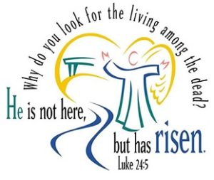

WE SING
Crown Him with many crowns,
The Lamb upon His throne;
Hark, how the heavenly anthem drowns
All music but its own!
Awake, my soul, and sing
Of Him who died for thee,
And hail Him as thy matchless King
Through all eternity.

Crown Him the Lord of life,
Who triumphed o'er the grave
And rose victorious in the strife
For those He came to save:
His glories now we sing,
Who died and rose on high,
Who died eternal life to bring
And lives that death may die.

Crown Him the Lord of love;
Behold His hands and side,
Those wounds yet visible above
In beauty glorified:
No angel in the sky
Can fully bear that sight,
But downward bends His burning eye
At mysteries so bright.

Crown Him the Lord of years,
The Potentate of time,
Creator of the rolling spheres,
Ineffably sublime!
All hail, Redeemer, hail!
For Thou hast died for me;
Thy praise shall never, never fail
Throughout eternity.

BLESSING

Minister God the Father,
by whose love Christ was raised from the dead,
open to you who believe the gates of everlasting life.
All Amen.
Minister God the Son,
who in bursting the grave has won a glorious victory,
give you joy as you share the Easter faith.
All Amen.
Minister God the Holy Spirit,
whom the risen Lord breathed into his disciples,
empower you and fill you with Christ’s peace.
All Amen.
Minister And the blessing of God almighty,
the Father, the Son, and the Holy Spirit,
be among you and remain with you always.
All Amen.

DISMISSAL
Minister God of our salvation, you have restored us to life
and brought us back again into your love
by the triumphant death and resurrection of Christ.
All Continue to fill us, empower us and heal us
as we go to live and work in the power of your Spirit,
to your praise and glory. Amen

Minister Alleluia. Christ is risen.
All He is risen indeed. Alleluia.

At the end of the service,
free tea and coffee and hot cross buns
are served at Gino’s café.

You are welcome to buy your own cooked breakfast,
which Gino is kindly supplying at a discounted rate.

Thank you to everyone who has made this service possible.
A special thank you to Melvyn Mills for all his practical help.

Thank you to Krome Technologies for printing this Service sheet
www.krome.co.uk
Thank you to Sainsburys for
supplying the Hot Cross Buns

Walton Churches Together

